**DP2 2020-2021**

Changelog Report D3

June Group #4

Repository

<https://github.com/rodddella/Acme-Planner.git>

Members

* Guillermo Diz Gil
* Francisco Rodríguez Pérez
* Carmen María Muñoz Pérez
* George Laurentiu Bogdan

Tutor

* Rafael Corchuelo Gil

Table of contents

Summary 3

Workload should not be verified when dates are wrong 3

Favourite links should have been removed 3

Provider and consumer roles should have been removed 4

The tasks were divided too much 5

Workload should not have more than two decimals and should not allow more than 59 in the decimal part 5

Default data on the forms 5

# Summary

This document contains a summary of the mistakes that we have found in the previous delivery (S2) and how have we corrected them.

# Workload should not be verified when dates are wrong

When a manager tried to create a task in the system whose dates were incorrect, either in the past or representing an incorrect time period, the workload was still checked, displaying unnecessary warnings to the user. This has been corrected by first checking if the dates are completely correct, thus ensuring that the workload can be checked.

Workload is no longer checked if dates are wrong

# Favourite links should have been removed

Due to a mix-up, the links corresponding to the favourites had not been removed from the project. All similar links have been removed completely, allowing for greater simplicity in the interface and user experience.

An anonymous principal no longer can see a "Favourite link"

# Provider and consumer roles should have been removed

As the title explains the roles provider and consumer (and all the data related to them) should be removed from Acme-planner since they are part of Acme-jobs.

Rermoved from the view

Removed from the data model

And the corresponding entities have also been removed.

# The tasks were divided too much

This caused some dependecies problems throughout the project’s development and affected our performance.

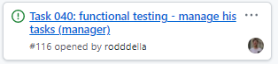

We fixed this along the S3 dividing the tasks ina feature level instead of in a functional requirements level.

# Workload should not have more than two decimals and should not allow more than 59 in the decimal part

As the title explains the workload should not have more than two decimals since the format is HH.MM. In addition, the decimal part must have a maximun value of 59 for the same reason.

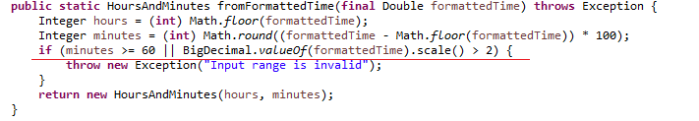

# Default data on the forms

The default data put on the forms should be removed for a better and improved user experience, since the user would have to delete the default data and then put the new data on the forms

# Navigate Problem

After an update of the framework we faced some problems with the tests, specifically with the navigate function since the method navigate has the assert "isSimpleQuery()” which assert that the second paremeter does not start with “&” or “?”, that assert give us problem with some test for instance:

@ParameterizedTest

@CsvFileSource(resources = "/administrator/spamWord/delete-positive.csv", encoding = "utf-8", numLinesToSkip = 1)

@Order(10)

**public** **void** deletePositive(**final** **int** id) {

**super**.signIn("administrator", "administrator");

**super**.navigate("/administrator/spam-word/show", String.*format*("&id=%d", id));

**super**.clickOnSubmitButton("Delete");

**super**.navigate("/administrator/spam-word/show", String.*format*("&id=%d", id));

**super**.checkPanicExists();

**super**.signOut();

}

We debate about various solution as for example commenting that assert on the framework and then we came to the conclusion that the best solution is simply to put a dot “.” before the ampersand. Like that:

**super**.navigate("/administrator/spam-word/show", String.*format*(".&id=%d", id));